Distributed System
HW #2

(Note: original code can be found in Blackborad)

- In Example1*.* code, what will be the result if we
  - Execute in order
    - Example1Sender localhost 10000 helloworld
    - Example1Receiver 10000

The sender will find a localhost 10000 and send the message; however, the receiver wasn’t initiallised, so it will still wait for an incoming datagram. It will continue to wait, receiving nothing until manually terminated, or the sender command is executed again.

  - Execute in order
    - Example1Receiver 10000
    - Example1Sender localhost 10000 hello world

The sender will receive an error and print out “This Program requires 3 command line arguments. This is because it is considering the “Hello” and the “world” as separate parameters. The receiver continues to wait for a datagram until manually terminated or a message is received.

  - Execute in order
    - Example1Receiver 10000
    - Example1Sender localhost 10000 “hello world”

The Receiver will print out “hello worl”. This is because the message is limited to 10 characters, including spaces. Java array index starts at zero, so the message is truncated to the index 9.

  - Execute in order
    - Example1Receiver 20000
    - Example1Sender localhost 10000 hello world
    - Example1Sender localhost 20000 howdy

The receiver, waits for a message. The first sender to local host 10000 prints a message “this program requires three command line arguments”. The second sender to localhost 20000 sends the message howdy. The receiver, still waiting for a message, prints out the message.

- In Example3*.* code, what will be the result if we
  - Execute in order
    - Example3Receiver localhost 10000 20000 received
    - Example3Sender localhost 20000 30000 sent

Both Receiver will wait for connection. The sender does connect to the receiver, but the Receiver is looking for port 10000 to connect to. Because they don’t connect, nothing is displayed.

  - Execute in order
    - Example3Receiver localhost 10000 20000 received
    - Example2SenderReceiver localhost 20000 30000 sent

Again the two sockets do not respond to eachother because they are attempting to connect to different sockets with values of 10000 and 20000. The SenderReceiver does connect to receiver, but the Receiver is attempting to connect to socket 10000. So nothing is displayed

- Modify the original Example1*.java code so that the receiver loops indefinitely to receive and output datagrams. Recompile. Then (i) start the receiver, (ii) execute the sender, sending a message “message 1”, (iii) in another window, start another instance of the sender, sending a message “message 2”. Does the receiver receive both messages? Capture the output.

The receiver does receive and print out both messages. By adding a While loop, the receiver continues to receive any datagram that is sent
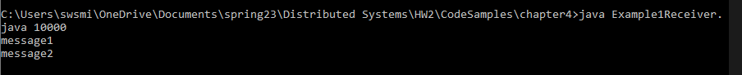
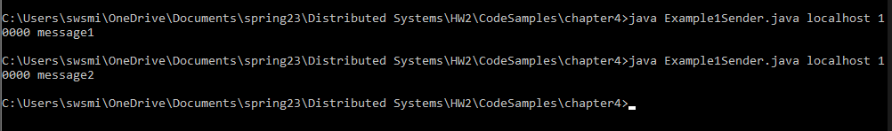

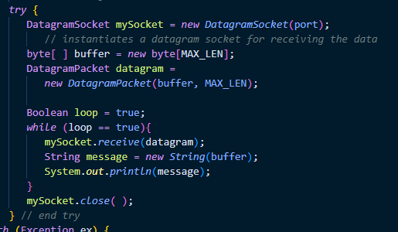

- This exercise guides you through experiments with connection-oriented datagram socket using code sample Example4*.*.
  - Compile and run Example4*.java. Start the Acceptor first, then the Requestor. Sample commands to do so are:
Example4ConnectionAcceptor 12345 Good-day!
Example4ConnectionRequestor localhost 12345
Describe and observe the outcome.
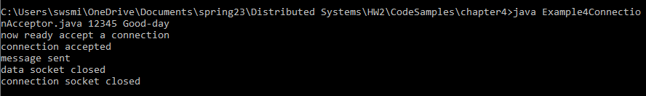

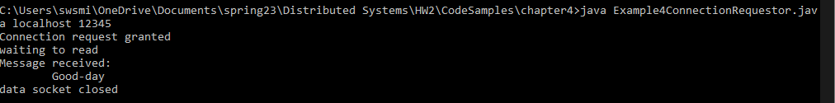

The acceptor awaits a connection and prints “now ready accept a connection” when running the requestor, the connection is made. Both print confirmation messages to the cmd. The message is received and prints. Both data sockets close, then the connection socket closes

  - Re-run the applications – this time reverse the order of the steps (i) and (ii). Describe and explain the outcome.

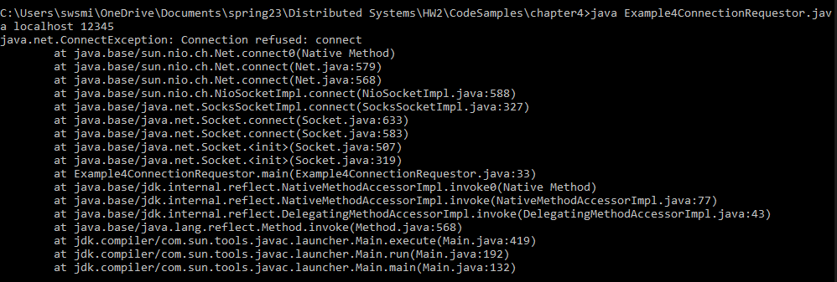

The requestor attempts to connect to port 12345, but there is no open port with that value, so it throws a connections exception error. Connection Refused: connect. When executing the Acceptor, it awaits a connection.

  - Add a time delay of 5 seconds (by using Thread.sleep( )) in ConnectionAcceptor just before the message is written to the socket. This will have the effect of keeping the Requestor blocked on reading for 5 extra seconds so that you can observe the blocking visually.

Both the acceptor and the requestor sleep for 5 seconds, before the same confirmation message is printed

- Modify the original Example5*.java so that the ConnectionRequestor sends a replying message to the ConnectionAcceptor after receiving a message from the Acceptor. The replying message should be displayed by the Acceptor. Hand in a event diagram, the program listings. And run outcome.

